# EXERCISES

1. Prove that $\sqrt{3J_{2}}$ reduces in triaxial compression to $\left|σ_{1}-σ_{3}\right|$ where $σ_{1}$ stands for the major principal stress and $σ_{3}$ for the minor principal stress.

$$\sqrt{3J_{2}}=\sqrt{\frac{1}{2}{{[(σ}_{1}-σ_{2})}^{2}+{{(σ}_{2}-σ_{3})}^{2}+{{(σ}_{3}-σ_{1})}^{2}]}$$

in triaxial compression, $σ_{2}{=σ}_{3}$

$$\sqrt{3J_{2}}=\sqrt{\frac{1}{2}(σ_{1}^{2}-{2σ}_{1}σ_{3}+σ_{3}^{2}+σ_{3}^{2}{+σ}_{1}^{2}-{2σ}_{3}σ_{1}})$$

$$\sqrt{3J_{2}}=\sqrt{(σ_{1}^{2}-{2σ}_{1}σ_{3}+σ_{3}^{2}})$$

$$\sqrt{3J_{2}}=\sqrt{{{(σ}_{1}-σ_{3})}^{2}}=\left|σ_{1}-σ_{3}\right|$$

1. Plot the von Mises yield criterion in $σ_{1}-σ_{3}$ plane for plane strain conditions with $ε_{2}=0$. The intermediate principal stress is given as .

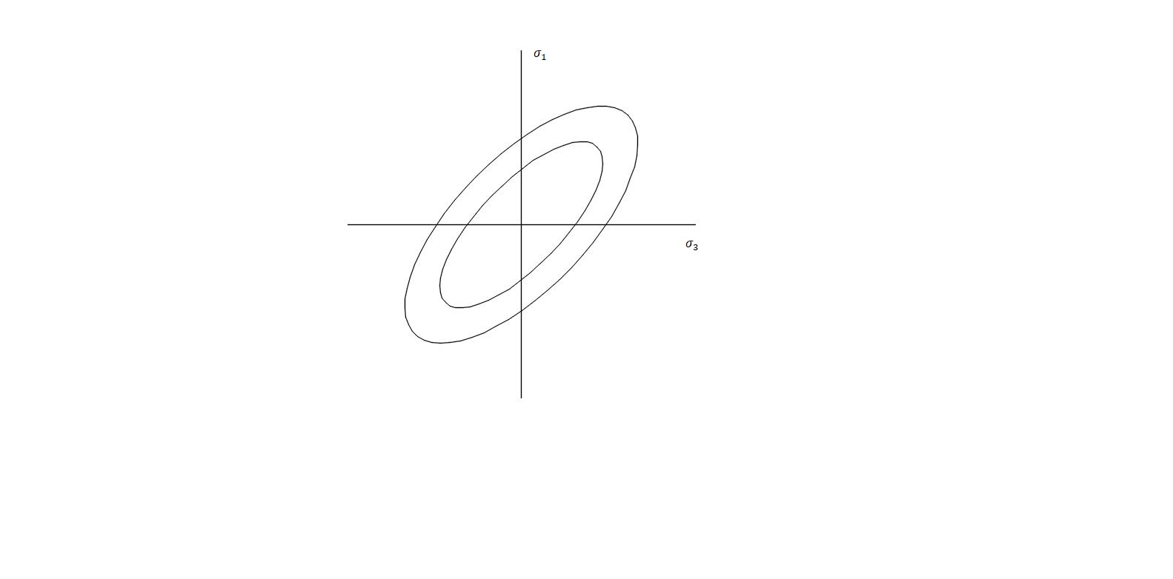

*Imagen que contiene antena, cielo

Descripción generada con confianza alta*

1. Prove the correctness $\frac{σ_{max}^{'}}{σ_{min}^{'}}≤\frac{1+\sin{φ^{'}}}{1-\sin{φ^{'}}}$ for cohesionless soil.

$$c=0$$

$$\sin{φ=\frac{R}{p}=\frac{\frac{σ_{1}^{'}-σ_{3}^{'}}{2}}{\frac{σ_{1}^{'}+σ_{3}^{'}}{2}}}=\frac{σ_{1}^{'}-σ_{3}^{'}}{σ_{1}^{'}+σ_{3}^{'}}$$

$$σ_{1}^{'}-σ_{3}^{'}=\left(σ_{1}+σ_{3}\right)\sin{φ^{'}}$$

$$σ_{1}^{'}=σ_{1}^{'}\sin{φ^{'}+}σ_{3}\sin{φ^{'}+σ_{3}^{'}}$$

$$σ_{1}^{'}(1-\sin{φ^{'})=}(1+\sin{φ^{'})σ_{3}^{'}}$$

$$\frac{σ_{1}^{'}}{σ_{3}^{'}}≤\frac{(1+\sin{φ^{'})}}{(1-\sin{φ^{'})}}$$

Check slide 25 from lecture class 1: Perfect Plasticity

1. Prove that $\frac{l_{1}}{l_{2}}≤\frac{3+\sin{φ^{'}}}{3-\sin{φ^{'}}}$ for Mohr-Coulomb.

$$\tan{θ}=\frac{2\sqrt{2}sin{φ}}{3-\sin{φ}}=\frac{l_{1}}{x} [1]$$

$$\tan{θ}=\frac{l_{2}}{x}=\frac{2\sqrt{2}sin{φ}}{3+\sin{φ}}$$

$$\frac{1}{x}=\frac{2\sqrt{2}sin{φ}}{3+\sin{φ}}=\frac{1}{l_{2}} [2]$$

Replacing equation [2] in [1]:

$$\frac{l_{1}}{l_{2}}=\frac{(2\sqrt{2}sin{φ})(3+\sin{φ})}{(3-\sin{φ)}(2\sqrt{2}sin{φ})}$$

$$\frac{l_{1}}{l_{2}}=\frac{(3+\sin{φ})}{(3-\sin{φ)}}$$

Check slide 27 from lecture class 1: Perfect Plasticity

1. Prove the correctness of external DP circle.

$$σ_{max}^{'}=\frac{(1+\sin{φ)}}{(1-\sin{φ)}}σ_{min}^{'}$$

$$p^{'}=\frac{σ_{max}^{'}+2σ_{min}^{'}}{3}$$

$$p^{'}=\left( \frac{1+\sin{φ+2-2\sin{φ}}}{3-3\sin{φ}}\right)σ_{min}^{'}$$

$$p^{'}=\left( \frac{3{-\sin{φ}}}{3-3\sin{φ}}\right)σ_{min}^{'} [1]$$

$$q=σ_{max}^{'}-σ_{min}^{'}=\left(\frac{1+\sin{φ}}{1-\sin{φ}}-1\right)σ_{min}^{'}$$

$$q=\left(\frac{2\sin{φ}}{1-\sin{φ}}\right)σ_{min}^{'} [2]$$

$$\frac{q}{p'}=\left(\frac{2\sin{φ}}{1-\sin{φ}}\right)*\left( \frac{3{-3\sin{φ}}}{3-\sin{φ}}\right)=\left(\frac{σ\sin{φ}}{3-\sin{φ}}\right)=M_{φ}$$

$$q=M_{φ}*p'$$

Check slide 32 from lecture class 1: Perfect Plasticity